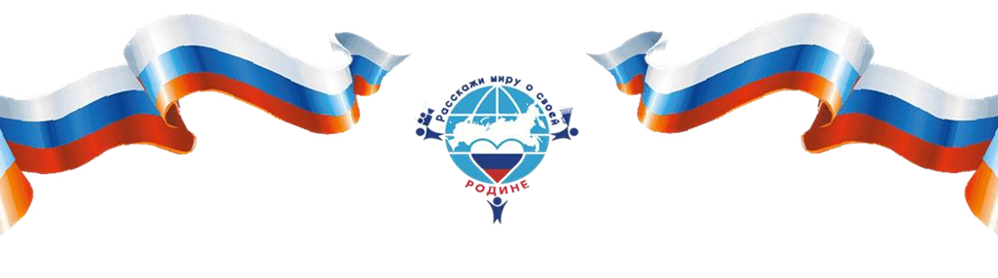
VI International Contest "Tell the World about Your Motherland"
Autonomous non-profit organisation "Innovative Centre for Development and Education of Children and Youth" supporting by the Committee on Labor, Social Policy and Veterans Affairs of the State Duma of the Federal Assembly of the Russian Federation, Department of Information and Press of the Ministry of Foreign Affairs of the Russian Federation, Federal Agency for the Commonwealth of Independent States, Compatriots Living Abroad and International Humanitarian Cooperation, "Russian World" Foundation, Moscow Pedagogical State University holds the VI International Contest "Tell the World about Your Motherland".
"Tell the world about your Motherland" is a contest aimed at developing friendly relations between representatives of different countries. Within the framework of the contest participants choose the most interesting events, traditions, memorable places of their motherland and tell about them to their peers from different countries in the format of a video clip or text page - presentation.
5,719 children from 89 regions of Russia and 34 countries submitted their works to the V International Contest "Tell the world about your Motherland". Over the entire period of the Contest, participants sent more than 10,550 works from 89 Russian regions and 66 countries.
Contest works are published on the Contest pages in social networks. The best works are broadcast by Russian and foreign mass media, take part in exhibitions at major venues.
The winners are determined by the Expert Council and the Honorary Jury based on the results of comparative analysis of the works that passed the competition in accordance with the stated evaluation criteria. The Honorary Jury includes M.V.
Zakharova (Department of Foreign Affairs and Press of the Ministry of Foreign Affairs of the Russian Federation), D.V. Polikanov (Rossotrudnichestvo), V.V. Kochin (Russian World Foundation), I.V. Radko (Rospatriotcentre) and others.
The Contest has two categories (text page - presentation and video) and four age categories. There are no age or any other restrictions for participation, anyone can submit a work from anywhere in the world!
Within the category "Text page presentation" foreign participants need to:
- Choose a theme: an event, landmark, tradition, cultural, historical, spiritual
value associated with their country or city;
- Then write about the event, sights, traditions, etc. with the addition of suitable colorful images (it can be handwritten photos, images from the Internet, drawings, etc.);
- The main text-page of the presentation is prepared by foreign-speaking contestants in any foreign language and then translated and duplicated in Russian.
- At the end it is necessary to convert the work into an electronic file of PDF, JPG format, file size-no more than 5 MB.
The video nomination requires:
- Choose the topic of the work: it can be a landmark, tradition, cultural,
historical value, etc...;
- Next, create a video on the selected topic in MP4 or AVI format, duration not more than 90 seconds, file size - not more than 100 MB.
- For foreign-speaking contestants the work is prepared in a foreign language with subtitles in Russian, also the work can be prepared in Russian with translation into a foreign language.
According to the results of the Contest, all participants receive electronic certificates, mentors receive electronic thank-you letters, and winners receive diplomas and memorable prizes (certificates for educational courses and entertainment centers, equipment, board games, art kits, souvenirs). All winners from Russia and foreign countries are invited to an award ceremony in Moscow with the participation of embassy representatives, government and public figures, and university professors.
Works are accepted until April 15, 2024. You can apply at www.youthy.ru.
More detailed information on the terms and conditions of the Contest can be found in the Regulations.
To participate, please read the presentation about the competition.
Tell the world about your Motherland!
Our contacts:
E-mail: telltheworldaboutmotherland@yandex.ru
Contact phone number: 89181500496 (Arina Nazar, head of the international block of the contest "Tell the world about your Motherland")
We're on social media:
Organiser's website
Group Vkontakte
Odnoklassniki group
Youtube-contest channel

The visual materials of the Contest can be viewed on the following link.

